**Submitted By-**

***Srijan Verma***

***1929057***

***CSCE-1***

**WT LAB ASSIGNMENT 31 MAR**

Q1

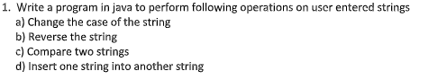

import java.util.Scanner;

public class Q1 {

static void case_change(String str){

StringBuffer newStr=new StringBuffer(str);

for(int i = 0; i < str.length(); i++) {

if(Character.isLowerCase(str.charAt(i))) {

newStr.setCharAt(i, Character.toUpperCase(str.charAt(i)));

}

else if(Character.isUpperCase(str.charAt(i))){

newStr.setCharAt(i, Character.toLowerCase(str.charAt(i)));

}

}

System.out.println("String after case conversion : " + newStr);

}

static void reverse_string(String str){

StringBuffer newStr = new StringBuffer(str);

newStr.reverse();

System.out.println("String after reversing : "+newStr);

}

public static void main(String[] args) {

Scanner sc = new Scanner(System.in);

System.out.print("Enter any String: ");

String myString = sc.nextLine();

case_change(myString);

reverse_string(myString);

System.out.print("Enter another String: ");

String myNewString = sc.nextLine();

if(myString.equals(myNewString))

System.out.print(myString+" and "+myNewString+" are Equal");

else

System.out.print(myString+" and "+myNewString+" are not Equal");

System.out.print("\nString after Concatenation : "+myString.concat(myNewString));

sc.close();

}

}

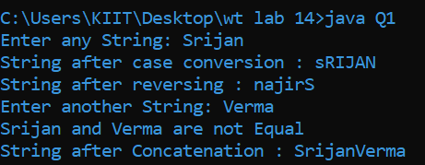

Q2

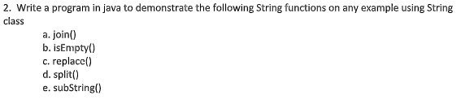

public class Q2{

public static void main(String[] args) {

String myString1 = "Srijan";

String myString2 = "Verma";

myString1 = String.join(" ",myString1,myString2);

System.out.println("String After Joining: "+myString1);

System.out.println("Is the Stirng is Empty: "+myString1.isEmpty());

myString1 = myString1.replace("Verma","Hi");

System.out.println("String After Replacing: "+myString1);

String[] words=myString1.split("\\s"); //splits the string based on whitespace

System.out.println("String After Spliting: ");

for(String w:words){

System.out.println(w);

}

System.out.println("A substring of the original string is: "+myString1.substring(6,10));

}

}

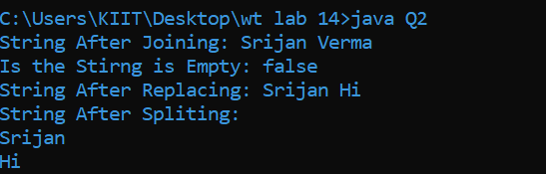

Q3

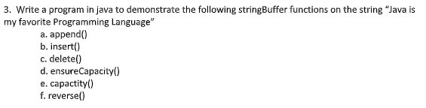

public class Q3{

public static void main(String[] args) {

StringBuffer myStr = new StringBuffer("Java is my favorite Programming Language");

System.out.println("Original String: "+myStr);

myStr.append(" so far");

System.out.println("After Appending: "+myStr);

myStr.insert(4," and Javascript");

System.out.println("After Inserting: "+myStr);

myStr.delete(0,9);

System.out.println("After Deleting: "+myStr);

System.out.println("Current Capacity: "+myStr.capacity());

myStr.ensureCapacity(120);

System.out.println("After Ensure Capacity: "+myStr.capacity());

myStr.reverse();

System.out.println("After Reverse: "+myStr);

}

}

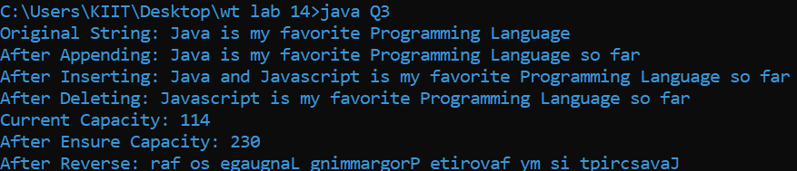

Q4



import java.util.*;

public class Q4

{

public static void main(String[] args) {

LinkedList<String> al=new LinkedList<String>();

al.add("Srijan");

al.add("Triyam");

al.add("Swarnavo");

al.add("Shubham");

al.add("Shubhayu");

Iterator<String> itr=al.iterator();

while(itr.hasNext()){

System.out.println(itr.next());

}

}

}

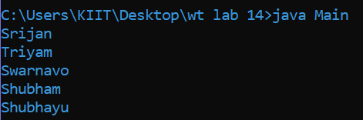

Q5

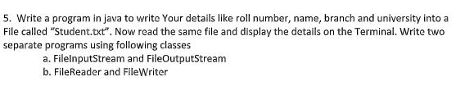

5A-

import java.io.FileInputStream;

public class Q5a{

public static void main(String[] args) {

try {

FileInputStream fin=new FileInputStream("Student.txt");

int i=0;

while((i=fin.read())!=-1){

System.out.print((char)i);

}

fin.close();

} catch (Exception e) {

System.out.println(e);

}

}

}

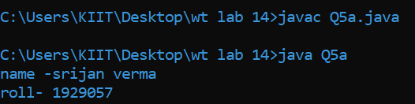

Q5b

import java.io.FileReader;

public class Q5b{

public static void main(String[] args) {

try {

FileReader fr = new FileReader("Student.txt");

int i;

while((i=fr.read())!=-1)

System.out.print((char)i);

fr.close();

} catch (Exception e) {

System.out.println(e);

}

}

}

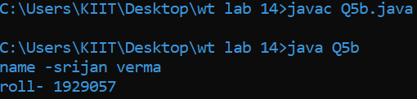

Q6



import java.io.BufferedReader;

import java.io.File;

import java.io.FileReader;

import java.io.FileWriter;

import java.io.IOException;

public class Q6{

static void modifyFile(String filename, String oldString, String newString){

File fileToBeModified = new File(filename);

String oldContent = "";

BufferedReader reader = null;

FileWriter writer = null;

try{

reader = new BufferedReader(new FileReader(fileToBeModified));

String line = reader.readLine();

while (line != null){

oldContent = oldContent + line + System.lineSeparator();

line = reader.readLine();

}

String newContent = oldContent.replaceAll(oldString, newString);

writer = new FileWriter(fileToBeModified);

writer.write(newContent);

}

catch (IOException e){

e.printStackTrace();

}

finally{

try{

reader.close();

writer.close();

}

catch (IOException e){

e.printStackTrace();

}

}

}

public static void main(String[] args) {

modifyFile("myNewFile.txt", "@", "#");

System.out.println("Converted all '"+(char)64+"' symbols to '"+(char)35+"' Symbol");

}

}

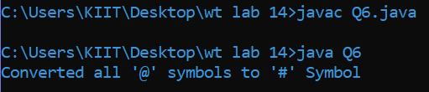

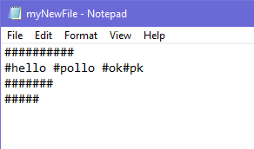

Q7



import java.io.*;

public class Q7{

public static void main(String[] args){

try{

FileReader fr = new FileReader("input.txt");

BufferedReader br = new BufferedReader(fr);

FileWriter fw = new FileWriter("output.txt", true);

int s;

while((s = br.read()) != -1) {

fw.write((char)s);

fw.flush();

}

br.close();

fw.close();

System.out.println("File copied successfully!");

}

catch(IOException e){

e.printStackTrace();

}

}

}

